**request.session**

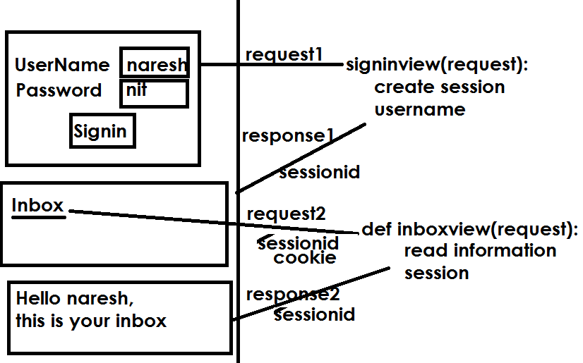

**What is sessionid**?

Django creates a unique 32-character-long random string called a session key and associates it with the session data. The server then sends **a cookie named sessionid , containing the session key, as value to the browser**. On subsequent requests, the browser sends the cookie sessionid to the server.

Create project

Create Application

Templates

Signin.html

<html>

<body>

    <form action="/signin">

        <h2>

            UserName <input type="text" name="t1"><br>

            Password <input type="password" name="t2"><br>

            <input type="submit" value="signin">

        </h2>

    </form>

</body>

</html>

**Inbox.html**

<html>

    <body>

    <h2>

        <a href="/inbox">Inbox</a>

    </h2>

    </body>

</html>

**Mails.html**

<html>

    <body>

        <h2>

            Hello {{uname}},<br>

            This is your inbox or mailbox

        </h2>

    </body>

</html>

**Views.py**

from django.shortcuts import render

# Create your views here.

def signinview(request):

    request.session['uname']=request.GET.get("t1")

    return render(request,"inbox.html")

def home(request):

    return render(request,"signin.html")

def inboxview(request):

    uname=request.session.get("uname")

    return render(request,"mails.html",context={"uname":uname})

urls.py

from django.contrib import admin

from django.urls import path

from app1 import views

urlpatterns = [

    path('admin/', admin.site.urls),

    path('home/',views.home),

    path('inbox/',views.inboxview),

    path('signin/',views.signinview)

]

Settings.py

INSTALLED_APPS = [

    'django.contrib.admin',

    'django.contrib.auth',

    'django.contrib.contenttypes',

    'django.contrib.sessions',

    'django.contrib.messages',

    'django.contrib.staticfiles',

    'app1',

]

import os.path

template_path=os.path.join(BASE_DIR,'templates')

TEMPLATES = [

    {

        'BACKEND': 'django.template.backends.django.DjangoTemplates',

        'DIRS': [template_path],

        'APP_DIRS': True,

